Typography / Text

Definition:
# Source: AI Source: Provided by: [Data Path: Persons Table -> ID Column: 1, Name_En Column: Motasem Essam] -> From: [Chatgpt (GPT‑5 Mini)] on [2/12/2026]
Typography / Text is a web page component that deals with how written content is presented on a web page. It includes headings, paragraphs, lists, and other text elements that make content readable and visually appealing.

Simple Definition
# Source: AI Source: Provided by: [Data Path: Persons Table -> ID Column: 1, Name_En Column: Motasem Essam] -> From: [Chatgpt (GPT‑5 Mini)] on [2/12/2026]
Typography / Text = all the text on a web page, including its style, size, and arrangement.

What Typography / Text Usually Includes
# Source: AI Source: Provided by: [Data Path: Persons Table -> ID Column: 1, Name_En Column: Motasem Essam] -> From: [Chatgpt (GPT‑5 Mini)] on [2/12/2026]
- Headings – <h1> to <h6> tags for titles and sections
- Paragraphs – <p> tags for body text
- Lists – ordered (<ol>) or unordered (<ul>) lists
- Blockquotes – quotes or highlighted text
- Emphasis / Styling – bold, italic, underline, color, font type
- Links within text – clickable words or phrases

Purpose of Typography / Text
# Source: AI Source: Provided by: [Data Path: Persons Table -> ID Column: 1, Name_En Column: Motasem Essam] -> From: [Chatgpt (GPT‑5 Mini)] on [2/12/2026]
- Make content readable and structured
- Highlight important information
- Improve user experience and accessibility
- Enhance website aesthetics and branding

Examples
# Source: AI Source: Provided by: [Data Path: Persons Table -> ID Column: 1, Name_En Column: Motasem Essam] -> From: [Chatgpt (GPT‑5 Mini)] on [2/12/2026]
- Blog post → headings for sections, paragraphs for content
- Product page → product name, description, features
- Portfolio → project titles, descriptions, client quotes
- News site → article titles, subheadings, and main text

Difference Between Typography / Text and Images / Multimedia
# Source: AI Source: Provided by: [Data Path: Persons Table -> ID Column: 1, Name_En Column: Motasem Essam] -> From: [Chatgpt (GPT‑5 Mini)] on [2/12/2026]
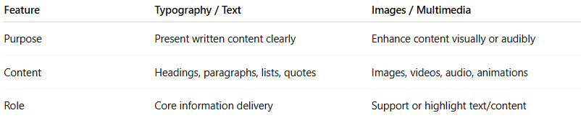
Feature | Typography / Text | Images / Multimedia
Purpose | Present written content clearly | Enhance content visually or audibly
Content | Headings, paragraphs, lists, quotes | Images, videos, audio, animations
Role | Core information delivery | Support or highlight text/content

